Relation Assignment

William Moore C21437002:

Relational Mode:l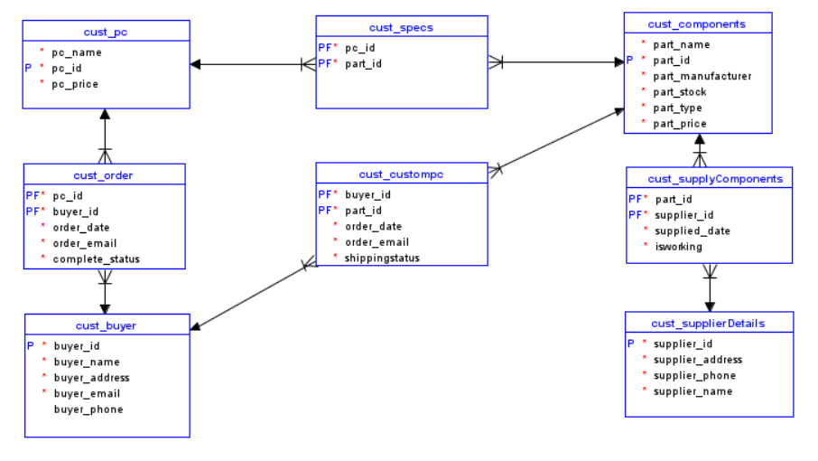Logical Model: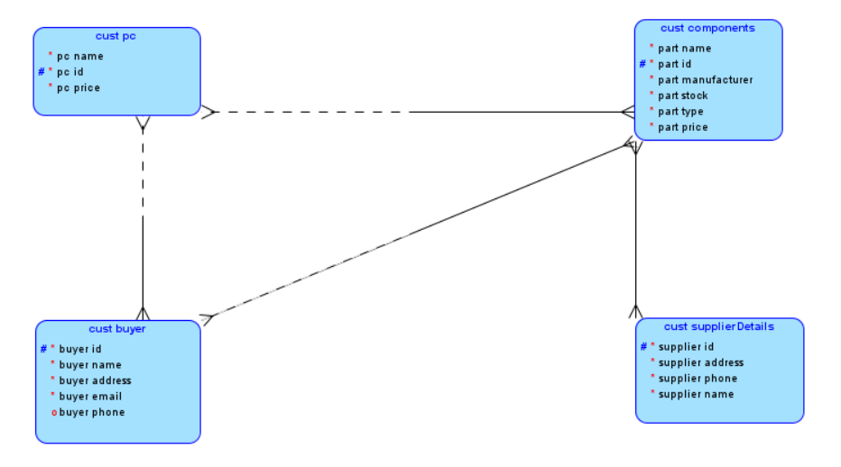

Tables:

cust_buyer: this table contains the information of the person who will be buying a custom pc and contains their necessary information, only phone number is not mandatory.

cust_pc: this is a table that contains pre-built custom pcs, has the id, name and price of the pc.

Cust_components: this table has all the information about the parts that go into a pc, like the name, brand, stock, and price per item.

Cust_supplierDetails: this contains the information of the supplier of the pc components so when the stock goes low they can be restocked.

Cust_order: is a relational table which connects the buyer to a prebuilt pc that they choose.

Cust_specs: is a relational table that connects the prebuilt pcs to the parts list. This is so that you can view what components are in each pc.

Cust_supplycomponents: is a relational table so that you know when a certain a part has been resupplied by a supplier

Cust_custompc: this relational table is for when the buyer wants to select custom components instead of buying a prebuilt pc.

Role:

I took up the role as the customer who is looking to buy a pc.  
I have insert and select access to cust_buyer , cust_order, and cust_custompc in order to create a customer/ account, create an order for a pre-built pc, and so that I can create my own pc.  
I also have select access to cust_pc and cust_components, so that I am able to see the information about what pcs we have and their price, as well as what components we have and the info about them.